<https://leetcode.com/discuss/interview-question/233724/Amazon-online-assessment-Longest-string-made-up-of-only-vowels>

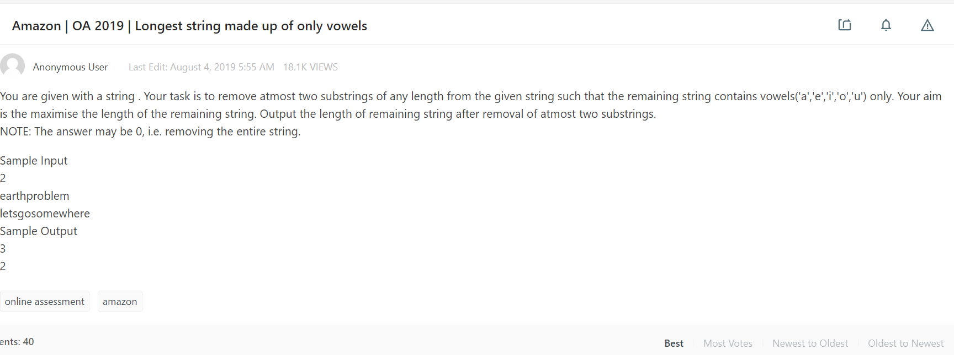

public class LongestVowels {

Set<Character> vowels = new HashSet<>(Arrays.asList('a','e','i','o','u'));

public int solution(String s){

int len = s.length();

int left = 0;

int right = len -1;

int ans = 0;

while (left <= right) {

if (vowels.contains(s.charAt(left))) {

ans++;

left++;

}

if (vowels.contains(s.charAt(right))) {

ans++;

right--;

}

if (!vowels.contains(s.charAt(left)) && !vowels.contains(s.charAt(right))) {

ans += longestVowels(s, left, right);

return ans;

}

}

return ans;

}

private int longestVowels(String s, int left, int right){

int ans = 0;

int count = 0;

for (int i = left; i <=right; i++){

if (vowels.contains(s.charAt(i))){

count++;

}else{

ans = Math.max(count, ans);

count = 0;

}

}

return ans;

}

}